# Mini Project Report on



**TWITTER CLONE**

# Submitted in partial fulfillment for award of BACHELOR OF TECHNOLOGY

**Degree In**

# COMPUTER SCIENCE & ENGINEERING

**2022-23**

**Under the Guidance of: Submitted By:**

**Ms. Rinki Tyagi Shivam raj Singh (2000330100210)**

**Assistant Professor Shivam Kumar (2000330100206) CSE Dept** **Vishal Sharma (200030010056)**

## DEPARTMENT OF COMPUTER SCIENCE & ENGINEERING RAJ KUMAR GOEL INSTITUTE OF TECHNOLOGY

**DELHI-MEERUT ROAD, GHAZIABAD**

**Affiliated to Dr. A.P.J. Abdul Kalam Technical University, Lucknow**

# November 2022

**LIST OF FIGURES**

**CHAPTER NO. PAGE NO.**

|  |  |  |  |
| --- | --- | --- | --- |
| 1 | Figure 3.1 | WHAT IS XML | 8 |
| 2 | Figure 3.2 | JAVA | 10 |
| 3 | Figure 3.3 | HTML + CSS | 11 |
| 4 | Figure 4.1: | HOMEPAGE | 12 |
| 5 | Figure 4.1: | OUR SERVICES | 12 |
| 6 | Figure 4.2: | TOURIST SPOTS | 13 |
| 7 | Figure 4.3: | REGISTRATION | 13 |
| 8 | Figure 4.4: | CONTACT US | 14 |
| 9 | Figure 4.5: | REGISTRATION FORM | 14 |

# TABLE OF CONTENTS

**CHAPTER NO. PAGE NO.**

### INTRODUCTION 4

* 1. ABSTRACT **5**
  2. PROBLEM DEFINITION **5**
  3. OBJECTIVE **6**
  4. NEED OF SYSTEM **6**

### HARDWARE AND SOFTWARE REQUIREMENTS 7

* 1. SOFTWARE REQUIREMENTS **7**
  2. HARDWARE REQUIREMENTS **7**

### IMPLEMENTATION ISSUES 8

* 1. HTML **8**
  2. CSS **10**

### SNAOSHOT 12

### ADVANTAGES OF TWITTER CLONE 15

### LIMITATIONS 16

### FUTURE SCOPE 17

### COCLUSION 18

### BIBLIOGRAPHY 19

# CHAPTER 1

## INTRODUCTION

Now a days twitter is an irresistible word when it comes to social media or microblogging site. We offer an attractive UI for user so they can present their ideas in a more personalized way .Twitter is a social media application that allows users to create tweets (that supports text, media, polls, etc.), react to tweets, retweet tweets, add comments, get notifications of engagements, and follow other users, to name a few.

Twitter works with the idea of [activity feeds](https://getstream.io/activity-feeds/) for showing timeline tweets and notifications.

Using Stream Feeds and the [React Activity Feeds SDK](https://getstream.io/react-activity-feed/tutorial/) from Stream, we will **create a clone of Twitter**. We will call this clone **Streamer**.

This article will be a series of tutorials broken into three parts which you can find at the end of the article or in the sidebar.

In addition to building the Twitter clone, you will also learn about the concept of activities and feeds and how it applies to keeping users engaged and connected with other users in your application. You will understand how to create relationships between feeds by subscribing one to the other and also how to manage notifications for different actions on activities.

## Abstract

The objective of the project is to develop a system that automates the processes and activities of a society and share people opinion freely. The purpose is to design a system using which one can perform all operations related to keeping opinion on a particular topic.

## Problem Definition:

* No use of Web Services and Remoting.
* Risk of mismanagement and of data when the project is under development.
* Less Security.
* No proper coordination between different Applications and Users.

This project will build a communications application similar to the popular application “Twitter.”This will be called “Twitter Clone” or Twic for short. Twic will allow interested persons to subscribe to download the application to their PC and/or mobile device and subscribe to the service. The service allows a user to post short updates and subscribe to updates by specific persons. The list of subscribers will be search able by name and subject.

## Objective

The project carried out under the title **“TWITTER CLONE”** is a sincere efforts towards increasing the speed and enhancing the Performance of managing a Private Work.

This has been tried to achieve thought making the whole system computerized along with the basic tasks of Private work and automation of all storage network. Certain additional feature like making new user to use this software, better user interaction etc.

## Need of the System:

There is always a need of a system that will computerize the tour booking and help to find the right tour destination. This system will reduce the manual operation required to maintain all the records of destination tour packages and their bookings. And also generates the various reports for analysis.

Thus, there is a big need of an online TWITTER CLONE, which provides all the above- mentioned facilities and many more.

# CHAPTER 2

## Hardware and Software Requirement

### Software Requirements:

* + Microsoft Windows 7/8/10 or Linux.
  + Notepad++ or any other text editor.
  + Chrome or any other browser.

**Hardware Requirements:**

* + Intel® Celeron® Processor 847, 1.10 GHz, or equivalent
  + Minimum of 512 MB
  + 3 GB or more Hard Disk Drive or above.

# CHAPTER 3

## Implementation Issues HTML



### Fig 3.1 WHAT IS HTML

HTML (Hypertext Markup Language) is the set of markup symbols or codes inserted in a file intended for display on a World Wide Web browser page.

The markup tells the Web browser how to display a Web page's words and images for the user. Each individual markup code is referred to as an element (but many people also refer to it as a tag).

Some elements come in pairs that indicate when some display effect is to begin and when it is to end.

* HTML stands for Hyper Text Markup Language
* HTML is the standard markup language for creating Web pages
* HTML describes the structure of a Web page
* HTML consists of a series of elements
* HTML elements tell the browser how to display the content
* HTML elements label pieces of content such as "this is a heading", "this is a paragraph", "this is a link", etc.

## CASCADING STYLE SHEET (CSS)

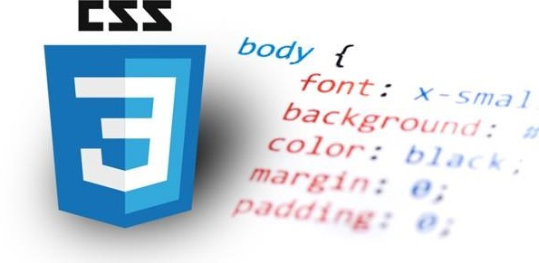

### Fig 3.2 CSS

Cascading Style Sheets (CSS) are a collection of rules we use to define and modify web pages. CSS are similar to styles in Word. CSS allow Web designers to have much more control over their pages look and layout. For instance, you could create a style that defines the body text to be Verdana, 10 point. Later on, you may easily change the body text to Times New Roman, 12 point by just changing the rule in the CSS. Instead of having to change the font on each page of your website, all you need to do is redefine the style on the style sheet, and it will instantly change on all of the pages that the style sheet has been applied to. With HTML styles, the font change would be applied to each instance of that font and have to be changed in each spot.

CSS can control the placement of text and objects on your pages as well as the look of those objects.

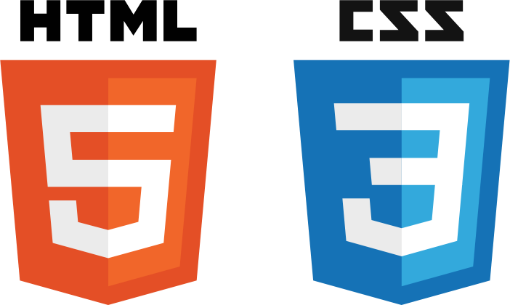

### Fig 3.3 HTML + CSS

HTML information creates the objects (or gives objects meaning), but styles describe how the objects should appear. The HTML gives your page structure, while the CSS creates the “presentation”. An external CSS is really just a text file with a .css extension. These files can be created with Dreamweaver, a CSS editor, or even Notepad.

The best practice is to design your web page on paper first so you know where you will want to use styles on your page. Then you can create the styles and apply them to your page.

# CHAPTER 4

**PART : 01**

## **CODE SCREENSHOT**

#### 4.1.1 Composing the TweetContent Component

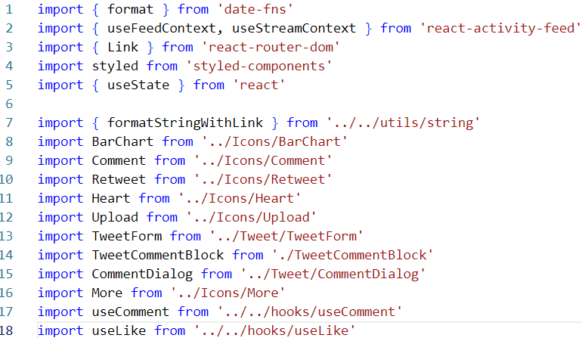

**4.1.2 FRONT END CODE**

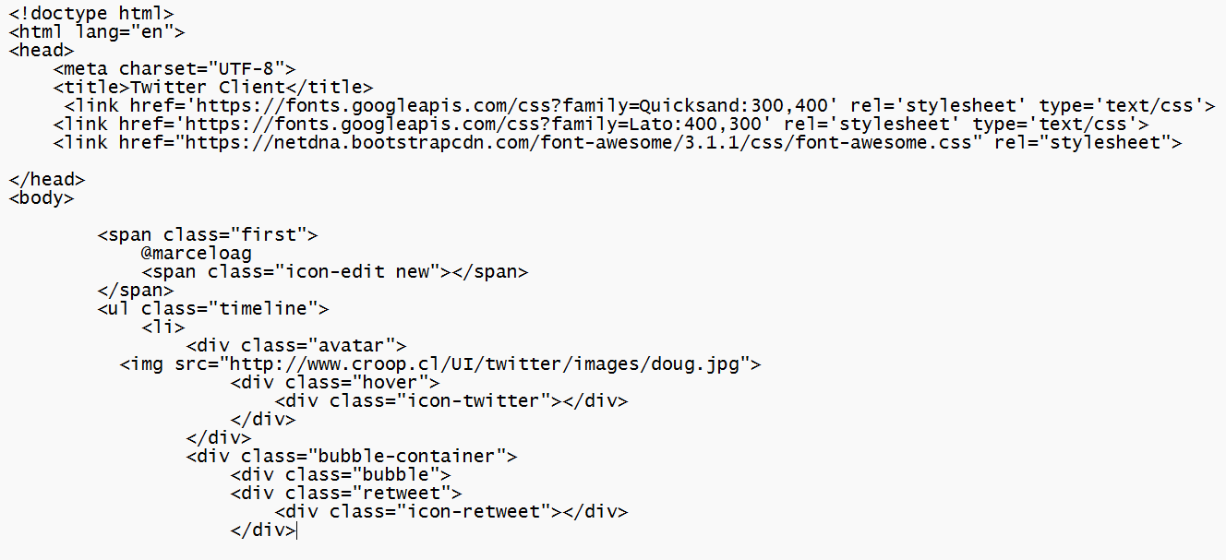

**4.1.3 CSS PART CODE**

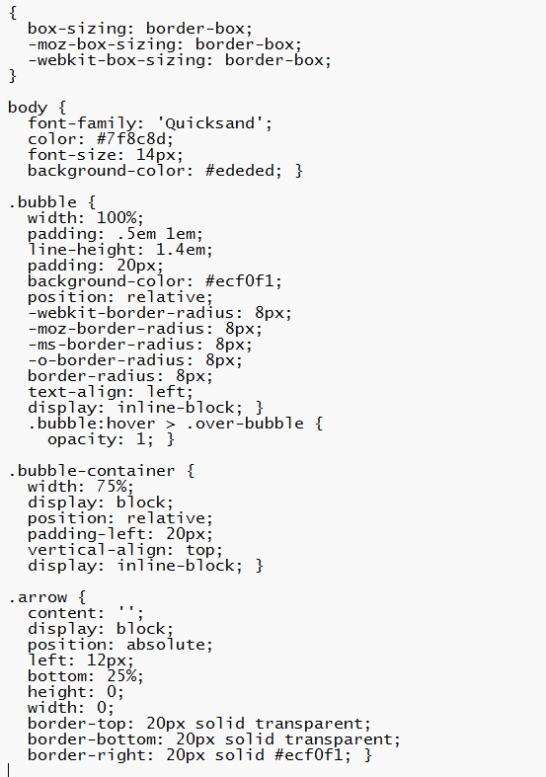

### PART : 02

**OUTPUT SCREENSHOT**

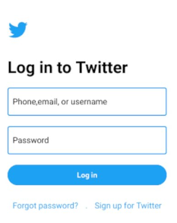

FIG.4.2.1 (LOGIN PAGE)

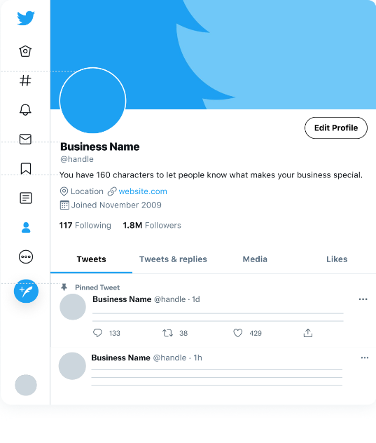

FIG. 4.2.2 (PROFILE PAGE)

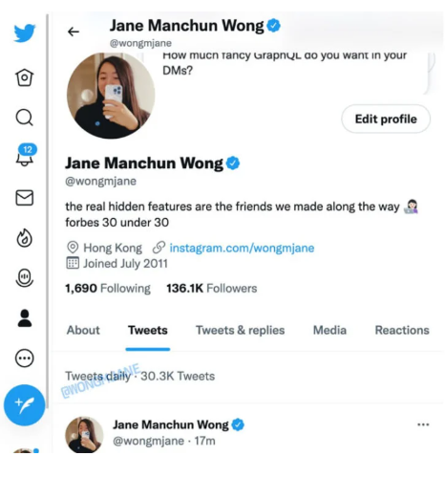

FIG. 4.2.3 (BLUE TICK ACCOUNT)

# CHAPTER 5

## Advantages of “TWITTER CLONE”

“TWITTER CLONE” provides various features, which complement the information system and increase the productivity of the system. These features make the system easily usable and convenient. Some of the important features included are listed as follows:

* ****Reach a wide audience:****Twitter has a large user base, which could include your potential customers. Using hashtags can help you reach an audience interested in a particular topic or in a particular location.
* ****Deliver customer service:****The platform allows direct two-way communication with your customers. Because it's a public interaction, if you do it well it shows your business in a positive light
* ****Brand identity:****Being on Twitter can help communicate your brand ethos and personality. This should help your business appeal to your target audience.
* ****Feedback:****Twitter can be a useful resource for gathering feedback from customers.
* ****Cost:****It is free of charge to set up a Twitter account. While paid ads are available, many businesses see benefits from organic posts and interactions.

# CHAPTER 6

## Limitations

Besides the above achievements and the successful completion of the project, we still feel the project has some limitations, listed as below:

* ****Resources:****Maintaining a presence on Twitter requires a time commitment. It's also important that the staff looking after the account have the right skills and training.
* ****Negative criticism:****Customers could complain publicly about product or services. Negative comments can reflect badly on your business. However dealing with complaints well can have a positive impact on your reputation.
* ****Time sensitive:****Unless you tweet at the right time, when your followers are online, your tweets could easily be missed.
* ****Spam:****Be wary of spam accounts on Twitter. In particular, do not click on suspicious links from users you don't know.
* ****Limitations:****You are restricted by Twitter's 280 character limit. It can take time to learn how to communicate effectively with brevity.

# CHAPTER 7

## Future Scope

It is worth mentioning that this project work is open for further enhancement, with the expectation that it becomes more robust and better enhanced; covering every single tourist sites.

For a modified system, the user need to just login into the

application and can find the routes,costs,hotels,adventure sports,transportations and book immediately and complete the booking process for a successful transaction.

In the aspect of tourism, Internet and web technologies have made more readily available information on tourist locations, accommodations, transportation, shopping, food, festivals, and other attractions, thus improving the whole tourism experience.

# CHAPTER 8

### CONCLUSION

Tourism is currently recognized as a global industry which is growing at a high rate like any other industry. Access to relevant and accurate information is at the heart of tourism. Here, the proposed project on Tourism Management System tries to bridge the gap by noting what a tourist perceives as relevant.

Hence, the aim of this project entails the design and implementation of a platform that will assist tourists in gaining access to travel to various tourist locations. The project also helped to provide knowledge about the latest technology used in developing web enabled application and client server technology that will be great demand in future.

# CHAPTER 9

### BIBLIOGRAPHY

**FOR HTML**

### https://developer.mozilla.org/en-US/docs/Web/HTML/Reference

**FOR CSS**

### https://developer.mozilla.org/en-US/docs/Web/CSS/Reference

**FOR OTHER USEFUL REFERENCES**

* + **<http://www.w3schools.com/default.asp>**
  + **<http://en.wikipedia.org/>**
  + **[https://www.youtube.com/playlist?list=PLu0W_9lII9agiCUZYRsvtGTXdx](https://www.youtube.com/playlist?list=PLu0W_9lII9agiCUZYRsvtGTXdxkzPyItg) [kzPyItg](https://www.youtube.com/playlist?list=PLu0W_9lII9agiCUZYRsvtGTXdxkzPyItg)**
  + **https:[//w](http://www.youtube.com/playlist?list=PLfqMhTWNBTe3H6c9OGXb5_)ww[.youtube.com/playlist?list=PLfqMhTWNBTe3H6c9OGXb5_](http://www.youtube.com/playlist?list=PLfqMhTWNBTe3H6c9OGXb5_) 6wcc1Mca52n**